BETAFIT PPE Ltd

Quality Policy Statement

It is our intention to provide our customers with PPE products that focus on quality, design, and comfort. We specialise in three sensory protection categories; Disposable RPE, Safety Eyewear and Hearing Protection. Our category focus and expertise ensures BETAFIT products consistently outperform regulatory requirements, are fully certified and provide superior protection for the end user.

We undertake to supply only safety equipment and/or related services that fully comply with the standards, regulations and claims made relating to those products and/or related services. Where appropriate, we will maintain up to date technical files and associated documentation to ensure that regulatory compliance information can be supplied upon request.

Where products are sourced from external organisations which hold technical files relating to the products being offered, we will request confirmation that these files are current, complete, contain appropriate conformity assessment information and, where relevant, regulatory compliance certificates and will take all necessary steps to confirm the validity of the compliance documentation held by that external supplier in respect of the products being sourced.

Where services are provided related to safety equipment sourced from external organisations, we will maintain approval from the manufacturer that the services provided are assessed and approved by the external organisation.

We are committed to continuous improvement and continuous effort will be made to improve product and service quality. We will continue to review any risks or opportunities that may affect our ethos of continual improvement.

There will be regular reviews of this policy, and all employees are encouraged to make suggestions for improvements to the quality system and this policy.

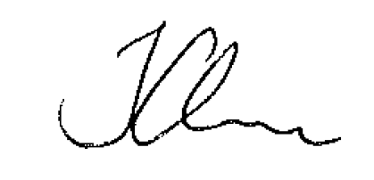

Joe Glass 27th September 2020
Business Administrator
BETAFIT PPE Ltd.

